A MULTIBIOMARKER ANALYSIS of POLLUTANT EFFECTS on ATLANTIC STINGRAY POPULATIONS in FLORIDA’S ST. JOHNS RIVER

by

TABLE OF CONTENTS

Page

Dedication iii

Acknowledgments iv

List of Tables vii

List of Figures viii

Abstract ix

Introduction 1

Materials and Methods 5

Study sites 5

Animal collections and biological sampling 6

Biomarker analysis 6

Liver sample preparation 6

Hepatic cytochrome P4501a1 (CYP1a1) activity 7

Hepatic glutathione-S-transferase (GST) activity 7

Hepatic uridine 5’-diphosphate glucuronosyltransferase activity 8

Protein normalization of enzyme activity 8

Biliary PAH metabolites (FACs) 8

Lipid peroxidation (LPO) 9

Statistical analysis 9

Results 11

2014-2016 survey 12

Integrated biomarker response (IBR) 13

2002-2005 survey 13

Temporal biomarker analysis in central Florida lakes 13

Discussion 14

2014-2016 survey 14

Temporal differences in central Florida lakes 19

Summary 23

Tables and Figures 24

Table 1 24

Figure 1 25

Figure 2 26

Figure 3 27

Figure 4 28

Figure 5 29

Figure 6 30

References 31

Vita 36

# List of Tables

Page

Table 1: Mean (± SE), range, and sample size for each biomarker measured in *D. sabina* liver and bile at each site from two different surveys (2002-2005 and 2014-2016)…………24

# List of Figures

Page

Figure 1: Map of sampling sites used in the present study………………………….….25

Figure 2: Mean (± SE) biomarker values measured in *D. sabina* collected between 2014 and 2016……………………………………………………………………….…………….26

Figure 3: An example of the star plots representing the seven biomarkers used to calculate the IBR/n index measured in *D. sabina* collected from each site during the survey conducted from 2014 to 2016………………….………………………………………………………...27

Figure 4: Mean IBR/n values (± SE) of *D. sabina* collected from each site. Letters indicate significant differences in IBR/n values between sites……………………………….…28

Figure 5: Mean (± SE) biomarker values measured in *D. sabina* collected from MSJR lakes between 2002 and 2005………………………………………………………………..29

Figure 6: Mean (± SE) biomarker values measured in *D. sabina* collected from MSJR lakes during the 2002-2005 and 2014-2016 surveys………………………………………...30

# Abstract

The goal of this study was to examine the potential health effects of organochlorine (OC) and polycyclic aromatic hydrocarbon (PAH) exposure on Atlantic stingray populations in Florida’s St. Johns River (SJR). Special emphasis was placed on identifying OC- and/or PAH-related effects in stingrays from areas of the lower (LSJR) and middle (MSJR) basins shown to possess elevated levels of these compounds, as well as characterizing baseline levels of pollutant exposure in the SJR shipping channel, which may be subjected to dredging in the near future, potentially resuspending and redistributing contaminated sediments and increasing pollutant-associated effects. To accomplish this, we measured OC and PAH biomarker levels in stingrays collected from contaminated and reference sites. We specifically examined the phase I detoxification enzyme, cytochrome P4501a1 (CYP1a1); the phase II detoxification enzymes, glutathione-S-transferase (GST) and uridine 5’-diphosphate glucuronosyltransferase (UGT); fluorescent aromatic compounds, PAH bile metabolites; and lipid peroxidation (LPO), cell membrane damage. Biomarker values collected between 2014 and 2016 were compared by site. Detoxification enzyme activity and LPO values from individuals collected from the three MSJR lakes between 2002 and 2005 were compared to those collected between 2014 and 2016. The data suggested that biomarker values from the SJR were variable, with elevated levels from Lake Jesup. Compared to reference estuaries, the LSJR has low biomarker values. This indicates that residing in certain portions of the MSJR is detrimental to stingray health, while residing in the LSJR is not. Lake Monroe and Lake George biomarker levels indicated reduced contaminant input over time, whereas Lake Jesup biomarker levels suggested the opposite. This study has developed a baseline for biomarker levels in the LSJR, allowing for the identification of dredging-induced changes to the system, and has identified temporal changes in biomarker levels from three MSJR lakes.

**Introduction**

Paragraph 1: Elasmobranch exposure studies. “Because of their relatively large size, high trophic position, etc., elasmobranchs can accumulate elevated levels…”

Paragraph 2: Gap in our understanding of **effects** of pollutant exposure on elasmobranchs.

Paragraph 3:

By focusing on these unique populations of elasmobranchs, that are relatively geographically restricted and less mobile than most elasmobranchs, and comparing them to the more mobile estuarine populations, we can attempt to address the question of not only pollutant exposure, but also pollutant effects.

In order to do this, we compared biomarkers of pollutant exposure and metabolism in resident freshwater populations of *Hypanus sabinus* in central Florida and nearby estuarine populations. The freshwater populations are relatively geographically restricted and thereby less mobile than their estuarine counterparts. This provides an opportunity to better examine the effects of biomagnification and bioaccumulation in elasmobranch populations.

The central Florida lakes provide relatively isolated ecosystems that each independently and naturally replicate an exposure study. The

The three lakes in the Lower St. John River used in this study are Lake George, Lake Monroe, and Lake Jesup. Tidal action has minor affects on these lakes.

Retention Time:

Water Velocity: Lower water velocity allows for pollutant-laden sediment to settle.

Are LPO values independent of CYP, GST, and/or CYP/GST values?

ANCOVA Model

Condition factor ~ cyp + gst + ugt + nph + bap + nap + lpo + interactions (e.g. nph:bap)+ error

LPO ~ cyp + gst + ugt + cyp:gst + cyp:ugt + error

AIC/BIC?

The St. Johns River (SJR) is an important resource to Northeast Florida and has long been recognized for its ecological, socioeconomic, recreational, and aesthetic benefits. Its eutrophic waters flow northward from its headwaters in Indian River County, through Jacksonville, to its mouth in Mayport, where they flow into the Atlantic Ocean. The navigation channel is a 20-mile reach of the lower St. Johns River (LSJR), which is a major transportation route to Jacksonville and its ports, and hosts two important US Navy installations. The Army Corps of Engineers has proposed dredging the channel from 40 ft to 47 ft beginning in 2018, with the project potentially lasting up to seven years. The project encompasses approximately 20 miles from the mouth of the river to the Talleyrand terminal near downtown Jacksonville. Dredging of the SJR has the potential to resuspend and redistribute contaminated sediments. A variety of industrial and agricultural sources have had a major impact on the water and sediment quality of the SJR causing several locations within the watershed to be designated as EPA Superfund Sites. Numerous studies have observed sediment concentrations of pollutants at specific sites in the LSJR that exceeded threshold effects levels, and in some cases probable effects levels (Cooksey and Hyland, 2007; Daskalakis and O’Connor, 1995; Delfino et al., 1991, 1992; Durell et al., 1997, 2004; Durell and Fredriksson, 2000; Higman et al., 2013; Keller and Schell, 1993; Pierce et al., 1988; Schell et al., 1993). Organochlorines (OCs) and polycyclic aromatic hydrocarbons (PAHs) are the pollutants of greatest concern in the LSJR, and are known to cause an array of negative health effects to organisms in aquatic systems.

Few studies have examined the effects of pollutants on resident wildlife in the SJR. Moreover, studies that have investigated this topic have only explored pollutant exposure and effects in a limited number of sites within this river system. For example, some past studies have examined biochemical and physiological responses in fish to bleached kraft pulp mill effluent discharged from the Georgia-Pacific Corporation in Rice Creek, a tributary of the LSJR, near Palatka, Florida (Bortone and Cody, 1999; Noggle et al., 2010; Sépulveda et al., 2004, 2002). In those studies, increased cytochrome P4501a1 (CYP1a1) activity (as measured using the ethoxyresorufin-*O*-deethylase [EROD] assay), decreased vitellogenin expression, and defeminization were observed in female fish, while decreased plasma sex steroid concentrations and gonadosomatic indices were observed in both sexes. The only other published research on pollutant exposure and effects in SJR wildlife was conducted by Gelsleichter et al. (2006), who examined hepatic OC concentrations in freshwater Atlantic stingray (*Dasyatis sabina*) populations in four central Florida lakes connected to the SJR, and found high OC levels in Lake Jesup (LJ) individuals along with elevated serum steroid concentrations and white blood cell counts. To the best of our knowledge, no studies have assessed pollutant exposure and effects in other regions of the SJR such as the highly-impacted shipping channel, and no studies have attempted to examine the impacts of pollution throughout the SJR on a single indicator species.

The Atlantic stingray is an abundant benthic elasmobranch that ranges from the coastal waters of the Chesapeake Bay to Campeche, Mexico (Bigelow and Schroeder, 1953). The Atlantic stingray prefers depths less than 25 m (Funicelli, 1975) and will burrow into the sediment, where persistent organic pollutants (POPs) such as OCs settle, in order to search for food and evade predation (Howard et al., 1977). Their diet primarily consists of small benthic crustaceans, echinoderms, polychaetes, and fish (Cook, 1994; Kaijura and Tricas, 1996), placing them towards the top of the food chain in the SJR, and increasing the potential for bioaccumulation and biomagnification of pollutants. This is a unique species because it is one of the few elasmobranchs that can survive in brackish and freshwater habitats. The presence of a permanent freshwater population in the SJR was first reported by McLane (1955), and this is the only known chondrichthyan population in North America that completes its entire life cycle in freshwater. Individual-based genetic connectivity analyses showed that freshwater SJR individuals were differentiated from southern US coastal populations of the same species, further reinforcing previous observations of a resident freshwater population (Personal communication, A M Bernard, May 1, 2015). Therefore, the Atlantic stingray could be considered an indicator species of ecosystem health in the SJR because of its broad distribution throughout this river system, its interaction with the sediment, and trophic position. It is also likely to exhibit strong site fidelity based on studies on euryhaline and marine populations of the same species, which have been observed year-round from Georgia to mid-Florida (Ramsden et al., 2017; Schwartz and Dahlberg, 1978; Snelson et al., 1988), and exhibit a high degree of site fidelity, migrating only to deeper water during the winter, if at all (Schmid, 1988; Brinton, 2015).

Biomarkers of pollutant exposure and effects in fish are often used for conducting environmental risk assessments (ERA) of contaminated aquatic habitats. Molecular and cellular biomarkers are considered early-warning signs of pollutant exposure and metabolism, which can manifest into cell-, organismal-, and population-level impacts (Bayne et al., 1985; van der Oost et al., 2003). Alterations in hepatic detoxification enzyme activity are generally the most sensitive biomarkers to anthropogenic contaminant-induced stress (Bucheli and Fent, 1995). Certain xenobiotic chemicals, such as PAHs, are quickly metabolized by phase I and phase II detoxification enzymes in fish and exposure and effects generally cannot be accurately assessed from their levels in fish tissue (Melancon et al., 1992). Instead, activity of these enzymes are often measured, along with the biliary concentrations of biotransformation products (Insausti et al., 2009). The detoxification process, which involves oxidation and reduction steps, can result in an increase in reactive oxygen species (ROS) production. Among other effects, this can result in cellular damage due to the oxidation of polyunsaturated fatty acids (lipid peroxidation [LPO]), DNA, or proteins (Stegeman et al., 1992). Using multiple biomarkers across a range of biological levels of organization allows for a greater understanding of the effect that pollutant exposure and stress has on the organism and subsequently the health of its ecosystem.

Multibiomarker approaches to ERA often use integrated statistical analyses to synthesize different biomarker responses into global indices (Adams et al., 1999; Beliaeff and Burgeot, 2002; Broeg et al., 2005; Narbonne et al., 1999). One method of multibiomarker analysis is the Integrated Biomarker Response (IBR), which standardizes the data and uses star plots, a multivariate graphical method, to visually integrate all responses to pollutant exposure (Beliaeff and Burgeot, 2002). This demonstrates the effects of different kinds of POPs using early-warning signals and allows for the evaluation of spatial and temporal changes in population and ecosystem health condition.

The goal of this study was to examine the potential health effects of OC and PAH exposure on Atlantic stingray populations in the SJR, and to characterize baseline levels of pollutant exposure in the shipping channel, which may be subjected to dredging in the near future, potentially resuspending and redistributing contaminated sediments, increasing pollutant-associated effects. To accomplish this, we measured the hepatic activity of phase I (CYP1a1) and phase II (glutathione-S-transferase [GST], uridine 5’-diphosphate glucuronosyltransferase [UGT]) detoxification enzymes, concentrations of fluorescent aromatic compounds (FACs) which reflect PAH metabolite concentrations in bile, and levels of LPO in liver from Atlantic stingrays collected from multiple sites in the SJR and regional estuaries, including known contaminated sites and less-impacted locations.

**Materials and methods**

*Study sites*

Biomarker levels were measured in Atlantic stingrays collected between 2002 and 2005 from northeast Florida, and between 2014 and 2016 from northeast Florida and southeast Georgia. The 2002-2005 survey included three central Florida lakes within the MSJR: Lake George (LG), Lake Monroe (LM), and Lake Jesup (LJ) (Figure 1); as part of an earlier published study on OC exposure, reproduction, and immune health (Gelsleichter et al., 2006). Variations in liver OC concentrations reflect what is known about environmental quality of these lakes (Durell et al., 1998; Durell and Frederiksson, 2000; Keller et al., 2004), which allowed the present study to consider LG as a control or reference lake. LJ sediment pollutant concentrations have not been reported, but it has been well-documented as one of Florida’s most degraded freshwater systems, and the environmental condition in LM has been reported to be intermediate to that of the two other lakes (Keller et al., 2004).

The 2014-2016 survey included the LSJR, the same three central Florida lakes, and three estuarine reference locations: Nassau River, Florida (NR); St Marys River, Florida (SMR); and St. Simons Sound, Georgia (GA) (Figure 1). The NR is a relatively small, undeveloped watershed that contains multiple natural preserves and state parks, which allows this site to serve as the control or reference estuary in the present study. This site can also serve as a reference for any possible changes resulting from the proposed dredging of the SJR shipping channel. The environmental condition of SMR and GA can be considered intermediate due to coastal development and known point sources of industrial pollutants, including OCs and PAHs.

*Animal collections and biological sampling*

Individuals collected from 2002 to 2005 were caught using trotlines baited with shrimp, while individuals collected from 2014 to 2016 were caught using trotlines, seine nets, and otter trawls. Stingrays were humanely euthanized via anesthesia without revival by immersion in tricaine methanesulfonate (Gilbert and Wood, 1957), and stored on ice for no more than 24 hours before dissection and tissue collection. Stingrays were weighed and measured (disk width) using an electronic balance and a tape measure, respectively. Liver was collected from all individuals, while bile was only collected from individuals caught between 2014 and 2016. Liver (~2-4 g) was excised from the distal portion of the right lobe and stored in cryovials, which were flash-frozen in liquid nitrogen, then stored at -80°C until used for detoxification enzyme and LPO analysis. Bile was sampled using a sterile ½ cc tuberculin syringe with a 27½-gauge needle and stored in light-protected vials at -80°C until used for FAC analysis. Previous studies have demonstrated that the quality of samples stored in this fashion was maintained and that biomarker levels did not decrease over time (Gelsleichter, unpublished data).

*Biomarker analysis*

*Liver sample preparation* Liver samples (~0.15-0.2 g) used to determine detoxification enzyme activity were homogenized using a 1:5 weight:volume ratio of tissue:homogenization buffer (10 mM Tris-base, 250 mM sucrose, 1 mM ethylenediaminetetraacetic acid, 0.2 mM dithiothreitol, 0.1 mM phenylmethylsulfonyl fluoride [Sépulveda et al., 2004]) using a FastPrep© - 24 bead homogenizer (MP Biomedicals, Inc., Solon, OH, USA). The homogenate was centrifuged at 8,000 g for 10 minutes, then the resulting supernatant was centrifuged at 12,000 g for 20 minutes. The final supernatant (S9 fraction) was isolated and stored in cryovials at -80°C until used for detoxification enzyme analysis.

Liver samples (~0.04-0.06 g) used to determine LPO were homogenized using a 1:100 weight:volume ratio of tissue:homogenization buffer (1X butylated hydroxytoluene in phosphate buffered saline). The homogenate was centrifuged at 10,000 g for 5 minutes, then the resulting supernatant (S9 fraction) was stored in cryovials at -80°C until used for LPO analysis.

*Hepatic cytochrome P4501a1 (CYP1a1) activity* Hepatic CYP1a1 activity was measured in the S9 fraction using the EROD assay following a protocol described in Sépulveda et al (2004). Samples were run in triplicate on a black fluorescence 96-well microtiter plate. The kinetic reaction was initialized by the addition of 10 μL of 5 mM β-NADPH to each well and the fluorescence (excitation: 530/25 nm, emission: 590/35 nm) was recorded once every minute for 10 minutes by a Synergy™ HT microplate reader (BioTek Instruments, Inc., Winooski, VT, USA) at 37°C. A resorufin standard curve was created using an eight-point serial dilution (0.15625-20 pmol) to convert the change in fluorescence per minute to the rate of resorufin produced during the assay (pmol/min) to estimate CYP1a1 activity.

*Hepatic glutathione-S-transferase (GST) activity* Total hepatic GST activity was measured using the Glutathione-S-Transferase Assay Kit (Cayman Chemicals, Ann Arbor, MI, USA). Samples were run in duplicate on a clear 96-well microtiter plate. The reaction was initialized by the addition of 10 μL of 1-chloro-2,4-dinitrobenzene (CDNB) to each well, which conjugates with reduced glutathione causing an increase in absorbance at 340 nm. The absorbance was measured once every minute for 10 minutes at 25°C. GST activity (nmol/min/ml) was calculated from the rate of change in absorbance per minute and the CDNB extinction coefficient at 340 nm (0.0096 μM-1 cm-1) (Habig et al., 1974).

*Hepatic uridine 5’-diphosphate glucuronosyltransferase (UGT) activity* Hepatic UGT activity was measured using a 4-methylumbelliferone (4MU) assay following the protocol from Collier et al (2000). Samples were run in duplicate on a black fluorescence 96-well microtiter plate. Each well received 20 μL of the S9 fraction sample, 70 μL of 100 μM 4MU, and 10 μL of 2 mM uridine 5’-disphosphate glucuronic acid (UDPGA), the latter of which initiated the reaction. The change in fluorescence (excitation: 340/11 nm, emission: 440/30 nm) was measured every 3 minutes for 9 minutes at 25°C to determine the rate of extinction of 4MU (nmol/min). A 4MU standard curve was created using an eight-point serial dilution (0.0156-2 μmol) to convert the change in fluorescence per minute to the rate of 4MU extinction during the assay (nmol/min) to determine UGT activity.

*Protein normalization of enzyme activity* Detoxification enzyme activity was normalized using protein concentrations (mg/mL) that were quantified colorimetrically using Protein Assay Dye Reagent Concentrate (Bio-Rad Laboratories, Richmond, CA, USA) and a serial dilution of bovine serum albumin (0.5, 0.25, 0.125, 0.0625 mg/mL) to create a standard curve (Bradford, 1976).CYP1a1 activity was expressed as picomoles of resorufin formed/min/mg protein; total GST activity was expressed as nanomoles of CDNB bound to reduced glutathione/min/mg protein; UGT activity was expressed as nanomoles 4MU lost/min/mg protein.

*Biliary PAH metabolites (FACs)* Concentrations of the biliary PAH metabolites naphthalene (NPH), pyrene (PYR), and benzo[*a*]pyrene (BAP) were quantified using fixed wavelength fluorescence (FF) following an amended protocol described in Insausti et al (2009). Bile samples were diluted 1/1000 in 48% ethanol then centrifuged at 10,000 g for 5 minutes. The resulting supernatant was transferred to a new vial and then samples were plated in triplicate on a black fluorescence 96-well microtiter plate for FF analysis at 25˚C. The excitation and emission wavelength pairs (nm) of 310/340, 340/380, and 380/440 (Lin et al., 1996; Aas et al., 2000) were used for detection of the hydroxylated PAH metabolites NPH, PYR, and BAP, respectively. Quantification was standardized using an eight-point dilution series (NPH: 0.08-10 ng/mL; PYR: 0.04-5 ng/mL; BAP: 7.81-1000 ng/mL).

*Lipid peroxidation (LPO)*  Lipid peroxidation was measured using the OxiSelect™ Thiobarbituric Acid Reactive Substances (TBARS) Assay Kit (Cell Biolabs, Inc., San Diego, CA, USA). Samples were run in duplicate on a 96-well microtiter plate at 25°C. A by-product of cellular damage via lipid peroxidation, malondialdehyde (MDA), was quantified in samples as it formed adducts with thiobarbituric acid (TBA). The MDA-TBA adducts were measured colorimetrically at an absorbance of 532 nm and an MDA standard curve was created using a nine-point serial dilution (0-125 μM) to determine the amount of MDA produced. MDA quantitation was adjusted for the amount of protein in each sample to express lipid peroxidation as nmol MDA produced/mg protein.

*Statistical Analysis*

Biomarkers from individual stingrays caught between 2014 and 2016 were grouped by site, sex, maturity, and size. The individuals with all seven biomarkers were analyzed using a multivariate analysis of covariance (MANCOVA) in which site, sex, and maturity were fixed factors and size was a covariate. The biomarker’s MANCOVA was first assessed for global significance using Wilk’s λ (*P* < 0.05). To determine which factor(s) caused the global differences between biomarker levels, data were analyzed using univariate ANOVAs, followed by Tukey’s B post-hoc test to determine homogenous subsets (*P* < 0.05). Data that failed tests of normality and/or equal variances were analyzed using a Kruskal-Wallis one-way ANOVA by ranks followed by Dunn-Bonferroni post-hoc test.

Star plots were used to display the panel of biomarkers at each site from the 2014-2016 survey. The area of a site’s polygon determined by the seven axes of the star plot was used to calculate the IBR. This was divided by the number of biomarkers (IBR/n) in order to standardize the IBR value since a larger number of biomarkers would increase the area of the polygon (Beliaeff and Burgeot, 2002; Broeg and Lehtonen, 2006). Multiple star plots were examined by changing the order of the biomarkers along the axes. The mean IBR/n values of each site were evaluated using univariate ANOVAs, followed by Tukey’s B post-hoc test (*P* < 0.05) to determine homogenous subsets and thus relative ecosystem health.

We had the opportunity to examine archived liver samples from a previous study in which individuals were collected from three central Florida lakes between 2002 and 2005 (Gelsleichter et al., 2006). Individuals that had all four possible biomarkers (CYP1a1, GST, UGT, and LPO) measured were analyzed using a one-way multivariate analysis of variance (MANOVA) to determine whether global differences existed between biomarker levels. The MANOVA was tested for significance using Wilk’s λ (*P* < 0.05). Due to limitations to sample sizes of individuals in which all four biomarkers were measured, data sets were also analyzed using one-way univariate analysis of variance (ANOVA) followed by Tukey’s B post-hoc test to determine homogenous subsets (*P* < 0.05). Data sets that failed tests of normality and/or equal variances were analyzed using a Kruskal-Wallis one-way ANOVA by ranks followed by Dunn-Bonferroni post-hoc test.

In order to determine if there were any temporal differences between biomarker levels in these lakes, unpaired t-tests (*P* < 0.05) were used to analyze biomarker levels between surveys at their respective sites.

Results are presented as means ± standard error (SE) with ranges and sample sizes by survey and site for comparison with other studies (Table 1). All statistical analyses were analyzed using SPSS® version 24 software (IBM, Armonk, NY, USA) and all figures were plotted using GraphPad Prism version 7.01 (GraphPad Software, Inc., La Jolla, CA, USA), except for the star plot which was plotted using Excel 2016 (Microsoft Corporation, Redmond, WA, USA).

**Results**

Overall, biomarkers were measured in a total of 139 stingrays from 2014 to 2016 representing GA (10), SMR (21), NR (13), LSJR (59), LG (13), LM (19), and LJ (4). There was not enough bile to analyze FACs in nine individuals from this survey. Hepatic detoxification enzyme activity and LPO levels were also measured in 54 stingrays from an earlier survey conducted from 2002 to 2005 in LG (10), LM (30), and LJ (14). Due to limited resources, LPO was only measured in 27 individuals from this survey. Quantifiable levels of all seven biomarkers were observed in each survey and at each site. Data on biomarker mean ± SE, range, and sample size for both surveys are shown in Table 1 for comparison with other studies.

*2014-2016 Survey*

The 130 individuals from the 2014-2016 survey that had all seven biomarkers measured were analyzed using a MANCOVA to evaluate variables potentially influencing biomarker levels: site, sex, maturity, and size. Only site (Wilks’ λ = 0.256, *F* (42, 487) = 3.901, *P* < 0.0001, partial η2 = 0.203) had a significant effect on biomarker levels. Insignificant factors on biomarker levels were maturity and size as well as the interactions of site and maturity; site and sex; maturity and sex; and site, sex, and maturity. Significant differences in levels of four of the seven biomarkers that were statistically compared among sites were observed. The biomarkers CYP1a1 (*F* (6, 109) = 4.840, *P* < 0.0001, partial η2 = 0.210), GST(*F* (6, 109) = 3.219, *P* = 0.006, partial η2 = 0.151), UGT(*F* (6, 109) = 3.349, *P* = 0.005, partial η2 = 0.156), and LPO (*F* (6, 119) = 3.091, *P* = 0.008, partial η2 = 0.145) were significantly affected by site and further analyzed using post-hoc tests.

Hepatic CYP1a1 activity in stingrays from GA, NR, and LJ was significantly greater than that from LG stingrays, with intermediate levels in stingrays from other sites (Kruskal-Wallis and Dunn-Bonferroni post-hoc test, *P* < 0.05; Figure 2.A). Hepatic GST levels were generally high in MSJR individuals compared to those from local estuaries, except SMR (ANOVA and Tukey’s B test, *P* < 0.05; Figure 2.B). LJ stingrays possessed elevated hepatic UGT activity, which was statistically greater than that detected in stingrays from the other sites (ANOVA and Tukey’s B test, *P* < 0.05; Figure 2.C). LPO levels in estuarine and LJ individuals were significantly greater than those from the LM and LG (Kruskal-Wallis and Dunn-Bonferroni post-hoc test, *P* < 0.05; Figure 2.G). Biliary BAP-like metabolites were variable in study animals with elevated levels in stingrays from GA, LG, and LJ, but differences among the seven sites were not statistically significant (ANOVA, *P* = 0.191; Figure 2.F).

*Integrated Biomarker Response (IBR)* The seven biomarkers analyzed during the 2014-2016 survey were represented in star plots in which the mean relative degree of response of a biomarker at each site was plotted on its corresponding axis (Figure 3). IBR/n values differed significantly among the seven sites (ANOVA and Tukey’s B, *P* < 0.05) with mean values ranging from 0.0198 (LG) to 0.4018 (LJ). Stingrays from LG had the lowest IBR/n indicating the best ecosystem health, while LJ stingrays had the highest IBR/n indicating the worst ecosystem health (Figure 4). Stingrays collected from LM and the estuaries had intermediate IBR/n values (Figure 4).

*2002-2005 Survey*

The 27 individuals from the 2002-2005 survey that had all four biomarkers measured were analyzed using a MANOVA to determine if global differences existed between sites, which was not the case (Wilks’ λ = 0.546, *F* (8, 42) = 1.858, *P* = 0.093). Due to low sample sizes caused by limited individuals with LPO measurements, individual biomarkers were further analyzed using an appropriate one-way ANOVA followed by post-hoc test analysis. Hepatic GST activity was elevated in LG and LM stingrays compared to LJ individuals (Kruskal-Wallis and Dunn-Bonferroni post-hoc test, *P* < 0.05; Figure 5.B). Hepatic UGT activity (ANOVA and Tukey’s B post-hoc test, *P* < 0.05; Figure 5.C) and LPO levels in liver samples (Kruskal-Wallis and Dunn-Bonferroni post-hoc test, *P* < 0.05; Figure 5.D) from LJ and LM stingrays were significantly greater than levels found in LG individuals.

*Temporal biomarker analysis in central Florida lakes*

Significant differences were observed in biomarker levels in stingrays collected from central Florida lakes at different time points. Hepatic CYP1a1 and UGT activity in LJ stingrays caught between 2014 and 2016 was significantly greater than those caught between 2002 and 2005 (*P* < 0.05; Figure 6.A and Figure 6.C, respectively). Hepatic GST activity in LG stingrays caught between 2002 and 2005 was significantly greater than those caught between 2014 and 2016 (*P <* 0.05; Figure 6.B). LPO in liver samples of LM stingrays caught between 2002 and 2005 was significantly greater than those caught between 2014 and 2016 (*P* < 0.05; Figure 6.D).

**Discussion**

*2014-2016 Survey*

The results of the present study indicate that the ecosystem health of the SJR is variable throughout the system and that Atlantic stingrays are exposed to elevated and potentially hazardous levels of pollutants, specifically in the case of LJ, which was designated to have the worst ecosystem health condition. The IBR/n value from LJ was more than five times greater than that of LM, the next most pollutant-impacted portion of the SJR. LG had the best ecosystem health condition of all sites, followed by the LSJR, which suggests that these portions of the SJR do not pose a significant threat to the Atlantic stingrays inhabiting them. Out of the estuarine locations sampled, the LSJR had the best ecosystem health condition, while populations inhabiting the SMR and NR experience elevated levels of pollutants. GA was observed to have intermediate pollutant-associated effects suggesting a delicate ecosystem health condition, comparable to LM. While the SJR was the site of greatest interest to this study, the reference sites were chosen based on proximity, with the knowledge that some, specifically GA and SMR, were considered to be pollutant-impacted. The SJR estuarine population does not seem to be negatively affected by pollutants, while pollutant-associated effects were observed in certain freshwater populations of the central Florida lakes, which provides further evidence to suggest that Atlantic stingray populations in portions of the MSJR may be living at the fringe of their physiological/ecological tolerance (Johnson and Snelson 1996; Snelson et al., 1997; Tricas et al., 2000; Gelsleichter et al., 2006).

The estuarine portion of the SJR was expected to have higher biomarker levels and thus an elevated IBR/n value compared to other local estuaries evaluated in this study. The data also did not reflect the many known point sources of OCs and PAHs in this system. The high degree of tidal flushing observed in the LSJR may alleviate some of the potential for pollutant-associated effects. The methodology of sampling within the LSJR did not allow for a high fishing effort within close proximity to these known contaminated sites. The catch rates were also very low from these sites, possibly indicating avoidance behavior. Random sampling within the system did however allow the data to be analyzed and interpreted as an ecological risk assessment of multiple systems, instead of providing another study evaluating biomarker levels in response to proximity to a particular point source (Bortone and Cody, 1999; Noggle et al., 2010; Sépulveda et al., 2004, 2002). The high degree of variation observed in a majority of the biomarkers from stingrays collected in the LSJR is however indicative of a relatively polluted site due to their ability to move in and out of contaminated sites.

There were however multiple stingrays within a relatively close proximity to known point sources in the LSJR that were observed to have a suite of elevated biomarker levels. Two such individuals were collected from Mill Cove, a portion of the LSJR adjacent to the shipping channel and terminals. They had the highest FACs observed in this study, one of which was also had elevated hepatic UGT levels and was collected near an oil refinery. Another individual collected near the shipping channel, terminals, and a power plant was observed to have elevated UGT, GST, and LPO levels. When examining the suite of biomarker responses of individuals, instead of populations, a more precise scale of PAH- and/or OC-related effects can be associated with known point sources. Evaluating fine scale differences within a large system like the LSJR would have diminished sample sizes, and was unnecessary when considering that the objective of this study was to evaluate relative ecosystem health between systems. This would have been further complicated by the multiple known contaminated sites within close proximity to each other and the possible additive and/or synergistic effects that the complex mixture of pollutants at each site might have on an individual.

There were no significant differences between sites for GST, the three FACs, and LPO during the 2014-2016 survey, suggesting that the differences observed in IBR/n values between sites were most sensitive to CYP1a1 and UGT. Detoxification enzymes are generally considered to be the most sensitive biomarkers of pollutant effects and can serve as a biological monitoring system for exposure to certain classes of xenobiotic pollutants, including PAHs and OCs. There is strong evidence that the induction of the phase I detoxification enzyme, CYP1a1, in fish is caused by exposure to PAHs and OCs, its best-known inducers, and that EROD activity is the most sensitive catalytic probe to determine the induction of CYP1a1 (Goksøyr and Förlin, 1992; Stegeman et al., 1992; Bucheli and Fent, 1995). The phase II detoxification enzymes, UGT and GST, are considered to be less sensitive to pollutant exposure (van der Oost et al., 2003). Hepatic UGT activity of fish significantly increased after exposure to PAHs and OCs in 52% of laboratory studies and 42% of field studies (van der Oost et al., 2003). Although UGT is not as sensitive as CYP1a1, it appears to be the most responsive to pollutant exposure of phase II parameters. In contrast, only 33% of field and laboratory studies observed a significant increase in total hepatic GST activity of fish after exposure to various xenobiotics, while no strong increases (> 500% of control) were reported (van der Oost et al., 2003). A study examining hepatic GST activity in Atlantic stingrays did not observe elevated levels after exposure to PAHs (James and Bend, 1980). Exposure to pollutants like polychlorinated dibenzodioxins (PCDDs) and PAHs can potentially cause both induction and inhibition of total hepatic GST (van der Oost et al., 2003), which is why it can be difficult to predict its reaction to a suite of pollutants.

Although FAC values varied considerably in different populations of Atlantic stingrays, there was no evidence to propose that exposure levels of these pollutants are significantly excessive at any of the seven sites examined in this study, suggesting that there is generally a low level of PAH contamination throughout the aquatic systems of northeast Florida and southeast Georgia. These results suggest that the significant variation between IBR/n values at different sites were associated with either different PAH congeners that induced a response in CYP1a1 and UGT, or that OC contaminants were responsible for these differences.

Out of the estuaries investigated in this study, SMR and NR had the worst ecosystem health condition, while GA had intermediate ecosystem health. The elevated IBR/n value of NR was unexpected as it has a relatively small, predominantly undeveloped basin mainly consisting of wetland and forested areas. However, one of the two stations examined for sediment quality standards had total PCB concentrations within the range at which toxicological effects may occur, as well as slightly elevated total PAHs, although they were not within the range at which toxicological effects may occur (Durell et al., 1998). The pollutant-impacted systems that are adjacent to the NR, the SMR and the shipping channel of the SJR, are a possible cause of the reduced ecosystem health observed in the NR. Future toxicological studies should investigate possible sources of pollution that might reduce the habitat quality for fish residing in the NR.

The ecosystem health of the SMR appeared to reflect what is known regarding environmental quality of this system. Sources of pollution in this moderately developed watershed include wastewater effluence, urban stormwater, atmospheric deposition, a U.S. Navy submarine base, and two paper mills. The Amelia River, which connects the SMR to the NR, had received 7,461,070 lbs of direct toxic discharges between 1990 and 1994, which ranked it as the 13th most polluted waterway in the U.S. (Savitz et al., 2000). Multiple studies have examined the consequences of this pollution, observing negative effects on fish including defeminization of female mosquitofish (*Gumbusia affinis holbrooki*) inhabiting waters that received bleached kraft mill effluent from one of the paper mills (Howell et al., 1980; Parks et al., 2001). The suite of pollutants and their metabolites in this system appear to have exerted toxicity related to oxidative stress as observed with elevated LPO liver levels in certain individuals.

The intermediate ecosystem health of GA likely was caused by the industries of the city of Brunswick, which have had a major impact on sediment and water quality of St. Simons Sound. There are four EPA designated Superfund sites located within its watershed, all of which are on the National Priorities List (NPL). The Brunswick Wood Preserving site borders Burnett Creek, a tributary of St. Simons Sound, and treated wood with creosote and pentachlorophenol from 1958 until 1991, when it caught fire. Another Superfund site known as LCP Chemicals has been a host to various industrial ventures from 1919 to 1994, including an oil refinery, power plant, paint manufacturing company, and most recently a chlor-alkali plant. During this time waste and refuse was discharged into holding pits and directly into Purvis Creek, a tributary of St. Simons Sound. Several agencies began sampling sediments and biota from this area and discovered concentrations as high as several parts per thousand of metals and organics, including PCBs (mostly Aroclor 1268) and PAHs (USFWS, 1994; USEPA, 1996). Advisories and closures have been posted for commercially and recreationally captured seafood from Gibson Creek, Purvis Creek, and the Turtle River in the early 1990s after the FDA found total PCBs in a fish fillet to be 2 mg/kg (USEPA, 2001).

*Temporal differences in central Florida lakes*

The observed variation in the biomarkers of significance (CYP1a1 and UGT) and IBR/n of Atlantic stingrays from the central Florida lakes during the 2014-2016 survey, as well as hepatic UGT levels and LPO liver levels from the 2002-2005 survey, appeared to reflect what is known about the environmental quality of these systems. Sediment OC concentrations from LG were lower than those from other mid-Florida lakes, including LM, which had concentrations within the range in which toxicological effects may occur (Durell and Fredriksson, 2000). Sediment PAH concentrations measured in mid-Florida lakes are mostly of pyrogenic origin and concentrations from LG were comparable to those from other mid-Florida lakes, while LM had slightly elevated levels, although not within the range that toxicological effects might occur (Durell et al., 1998). Sediment pollutant concentrations have not been reported for LJ, but it has been reported as one of Florida’s most degraded freshwater systems (Keller et al., 2004). A previous study compared hepatic OC concentrations in Atlantic stingrays from central Florida lakes and determined that they contained low (LG), intermediate (LM), and high (LJ) levels (Gelsleichter et al., 2006), reflecting the trends observed in the 2014-2016 survey for CYP1a1 and IBR/n. In fact, the OC liver levels of individuals from LM and LJ were higher than individuals from the Tampa Bay estuary (Gelsleichter et al., 2006), which is generally considered to be the most pollutant-impacted estuary on Florida’s Gulf coast (Seal et al., 1994; Carr et al., 1996). They were also observed to have higher DDX (dichloro-diphenyltrichloroethane and metabolites and isomers) and CHL (chlordane) liver concentrations than Atlantic stingrays from the Indian River Lagoon estuary (Weijs et al., 2015).

Elevated 2002-2005 hepatic GST activity was observed in stingrays from LG and LM, while elevated hepatic UGT activity and liver LPO levels were observed in stingrays from LM and LJ. The contradiction of hepatic GST activity with hepatic UGT activity and liver LPO levels in Atlantic stingrays from LG and LJ suggests that hepatic GST activity in this species may be inhibited by exposure to the suite of pollutants found in LJ. The historical inconsistency of induction, as well as the possibility of inhibition, of total hepatic GST in fish after exposure to pollutants (van der Oost et al., 2003) limits indicates that it might not be as responsive to pollutants as the other two detoxification enzymes examined in the present study. Additional validation of hepatic GST activity as an effective biomarker for the Atlantic stingray is necessary.

Pollutant-associated effects observed in Atlantic stingrays collected from LJ are likely due to current and historical sources of pollutants including wastewater effluent, urban stormwater, agricultural runoff, recreational boating, atmospheric deposition, and hydrologic changes (Keller et al., 2004). LJ is an appendage of the SJR with a watershed that includes a portion of the greater Orlando metropolitan area, which has seen rapid development and increases in population. Construction of a causeway at the mouth of the river in the 1950s reduced water exchange with the SJR resulting in further reduction of water quality. These hydrologic changes have decreased the lake’s ability to flush environmental pollutants with a mean hydrologic residence time estimated to range from 82 to 99 days, much greater than the 9 to 34 days estimated for LM (Keesecker, 1992; Keller et al., 2004). The reduced water flow has caused an increase in the deposition of organic-rich sediments, which helps to further trap anthropogenic pollutants in this system (Keller et al., 2004).

Decades of observed declines in environmental quality and sportfish populations led to the development of a Basin Management Action Plan (BMAP) in 2010 (FDEP, 2010). As part of the BMAP, the St. Johns River Water Management District (SJRWMD) has removed berms at the mouth of the river in order to facilitate greater flushing of the system with the SJR, but water quality parameters evaluated between two periods, 1995 to 2000 and 2009 to 2014, observed no significant decreases in trophic state index (TSI), which includes total phosphorus, water column total suspended solids, and chlorophyll-α concentrations (FLDEP, 2015). A separate study observed no significant changes in water quality in LJ from 1991 to 2002 and a decline in water quality in an upstream segment of the SJR between LJ and Lake Harney from 1996 to 2002 (Keller et al., 2004). Temporal trends of hepatic CYP1a1 and UGT activity in Atlantic stingrays in the present study have revealed that pollutant-associated effects have increased in LJ between the 2002-2005 and 2014-2016 surveys, suggesting continued degradation of a system in which stingrays were observed to have altered endocrine and immune function (Gelsleichter et al., 2006).

Elevated hepatic GST and UGT activity, as well as liver LPO levels, were observed in LM stingrays during the 2002-2005 survey. Temporal trends of LPO indicate that pollutant-associated effects have decreased in LM between the 2002-2005 and 2014-2016 surveys. Previous studies have provided evidence that reproductive fitness of freshwater stingrays is threatened by anthropogenic impacts in LM. A lack of gametogenesis and subsequent complete reproductive failure was observed in the LM population during the 1991-1992 breeding season (Johnson and Snelson, 1996). Even when reproduction was successful, stingray serum concentrations of gonadal steroids were lower in the LM population than their estuarine counterparts (Snelson et al., 1997; Tricas et al., 2000). A large number of non-pregnant mature female stingrays was observed by Gelsleichter et al. (2006) during the 2003 sampling period, but the occurrence of pregnant females during the 2004 sampling period suggests that these abnormalities were caused by environmental factors other than OC pollution. Variations in conductivity were hypothesized to be a contributing factor to the isolated reproductive abnormalities observed in this population (Johnson and Snelson, 1996; Gelsleichter et al., 2006), potentially caused by the rapidly fluctuating water quality of this lake. LM is subject to changes caused by the degradation of down-stream portions of the SJR, namely LJ (Keller et al., 2004). The decrease in pollutant-associated effects in the present study between the two sampling periods may just be indicative of a brief improvement of water quality in May and September, 2016, when these individuals were collected.

Stingrays collected from the central Florida reference site, LG, during the 2002-2005 survey had low hepatic UGT activity and liver LPO levels. When comparing temporal trends of biomarkers from LG, only total hepatic GST activity was significantly different between surveys. TSI has been the parameter of greatest concern in this system, which has not changed between the two surveys, but starting in 2012, mercury in fish tissue became a parameter of concern (FLDEP, 2006; 2012). Fish exposed to low doses of mercury have been observed to exhibit significantly reduced hepatic GST activity (Mela et al., 2013). The apparent increase in mercury in LG may have caused the reduction in GST levels observed between the two surveys, but again, variations in GST levels need to be interpreted carefully. If GST is indeed inhibited by exposure to pollutants that are uniquely elevated in central Florida lakes, such as OCs, this change in GST between surveys could be the result of changes in agricultural practices. Between 2007 and 2012, there was a 10% increase in farms and a 27% increase in farmed acres in Volusia County and an 11% increase in farms and a 21% increase in farmed acres in Marion County, both part of the watershed of Lake George (U.S. Department of Agriculture). Another interesting observation was the slightly elevated biliary BAP levels in four LG individuals from the 2014-2016 survey. The unexpected levels of this high molecular weight, pyrogenic PAH may be due to the U.S. Navy’s Pinecastle Bombing range located in the Ocala National Forest, which borders the lake’s east shoreline. LG is a minimally contaminated site compared to most other central Florida lakes, and northeast Florida estuaries, and can be considered a control or reference lake.

*Summary*

Examining the suite of biomarkers from this study provides the most valid basis for ecotoxicological interpretation, which supports previous hypotheses that Atlantic stingrays residing in the central Florida lakes are living at the edge of their physiological/ ecological tolerances, periodically experiencing stresses that limit reproduction and survival (Johnson and Snelson 1996; Snelson et al., 1997; Tricas et al., 2000; Gelsleichter et al., 2006). LJ was the most pollutant-impacted site and its ecosystem health deteriorated between surveys, which is possibly due to its long hydrologic residence time and inability to flush pollutants. Habitat remediation is crucial for this system and further degradation could possibly cause additional negative population level effects. The LSJR was not as affected by pollutants as expected, which may be a function of tidal flushing and/or the methodological parameters of this study. However, certain stingrays collected in close proximity to known contaminated sites were observed to have a suite of elevated biomarkers. Hepatic CYP1a1 and UGT activity appeared to be the most sensitive biomarkers in Atlantic stingrays. Biliary PAH metabolite levels suggest a low level of contamination throughout northeast Florida and southeast Georgia. This study has determined baseline biomarker levels for Atlantic stingrays, which can be used to evaluate potential changes in ecosystem health due to dredging.

*Table 1.*Mean (± SE), range, and sample size for each biomarker (CYP1a1 = cytochrome P4501a1; GST = glutathione-S-transferase; UGT = UDP glucuronosyltransferase; NPH = naphthalene; PYR = pyrene; BAP = benzo[*a*]pyrene; LPO = lipid peroxidation) measured in *D. sabina* liver and bile at each site (GA = St. Simons Sound, Georgia; SMR = St. Marys River; NR = Nassau River; LSJR = lower St. Johns River; LG = Lake George; LM = Lake Monroe; LJ = Lake Jesup) from two different surveys (2002-2005 and 2014-2016).

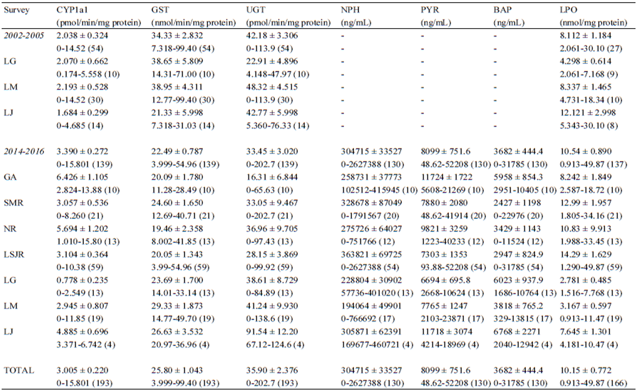

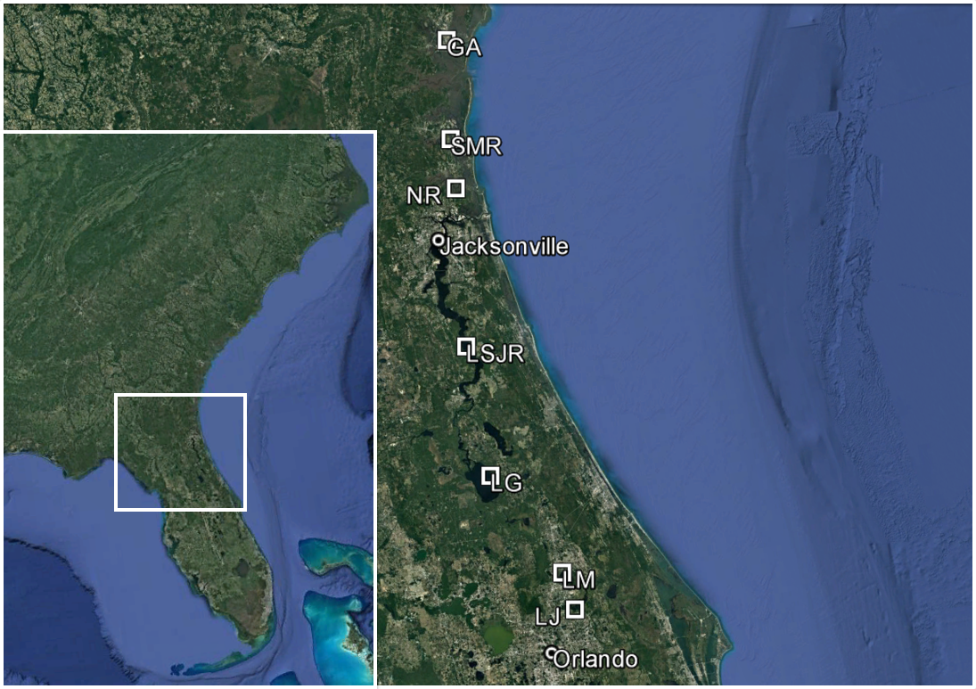

*Figure 1.* Map of sampling sites used in the present study. GA = St. Simons Sound, Georgia; SMR = St. Marys River; NR = Nassau River; LSJR = lower St. Johns River; LG = Lake George; LM = Lake Monroe; LJ = Lake Jesup.



**A B C**

**D E F**

**G**



**A A A A A A B**



**A B AB B C BC AB**

*Figure 2.* Mean (± SE) biomarker values of A) CYP1a1, B) GST, C) UGT, D) NPH, E) PYR, F) BAP, and G) LPO measured in *D. sabina* collected from St. Simons Sound (GA), St. Marys River (SMR), Nassau River (NR), lower St. Johns River (LSJR), Lake George (LG), Lake Monroe (LM), and Lake Jesup (LJ) between 2014 and 2016. Letters indicate significant differences between sites in CYP1a1 (Kruskal-Wallis and Dunn-Bonferroni post-test, *P* < 0.05) and UGT (ANOVA and Tukey’s B post-hoc test, *P* < 0.05). Sample sizes are beneath each site.

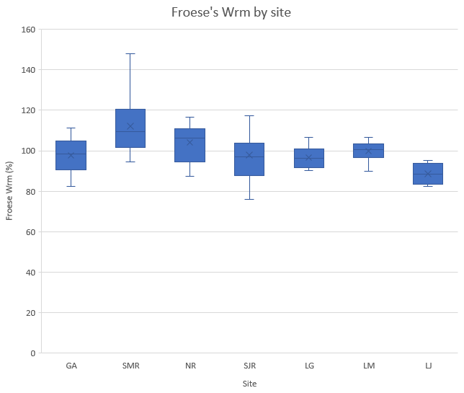

*Figure 3.* An example of the star plots representing the seven biomarkers (CYP1a1, GST, UGT, NPH, PYR, BAP, and LPO) used to calculate IBR/n measured in *D. sabina* collected from St. Simons Sound (GA), St. Marys River (SMR), Nassau River (NR), lower St. Johns River (LSJR), Lake George (LG), Lake Monroe (LM), and Lake Jesup (LJ) during the survey conducted from 2014 to 2016. Each of the seven axes of the star plots represents the relative degree of response of one biomarker at its respective site. Color lines represent different sampling sites (legend).

*Figure 4.* Mean IBR/n values (± SE) of *D. sabina* collected from St. Simons Sound (GA), St. Marys River (SMR), Nassau River (NR), lower St. Johns River (LSJR), Lake George (LG), Lake Monroe (LM), and Lake Jesup (LJ). Letters indicate significant differences in IBR/n values between sites (ANOVA and Tukey’s B post-hoc test, *P* < 0.05).

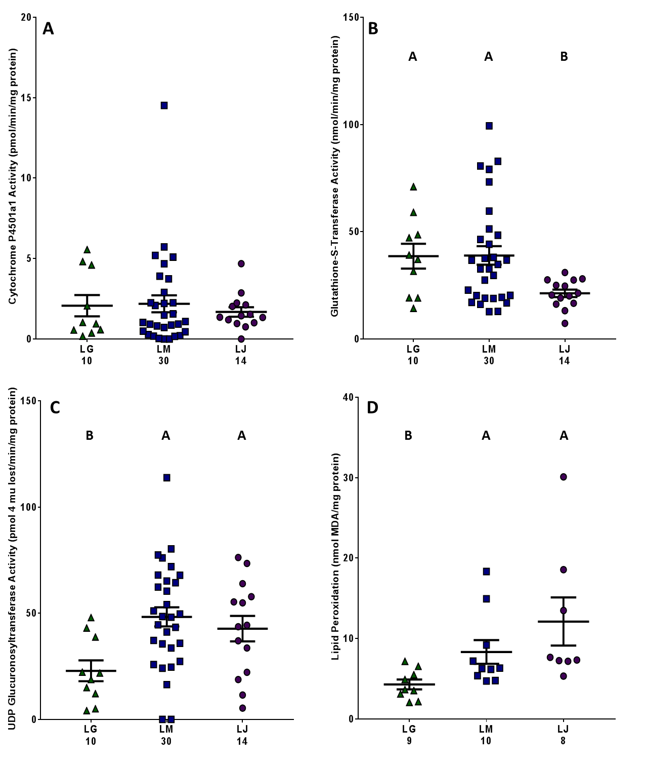

*Figure 5.* Mean (± SE) biomarker values of A) CYP1a1, B) GST, C) UGT, and LPO measured in *D. sabina* collected from Lake George (LG), Lake Monroe (LM), and Lake Jesup (LJ) between 2002 and 2005. Letters indicate significant differences between sites in GST and LPO (Kruskal-Wallis and Dunn-Bonferroni post-test, *P* < 0.05) and UGT (ANOVA and Tukey’s B post-hoc test, *P* < 0.05). Sample sizes are beneath each site.

*Figure 6.* Mean (± SE) biomarker values of A) CYP1a1, B) GST, C) UGT, and D) LPO measured in *D. sabina* collected from Lake George (LG), Lake Monroe (LM), and Lake Jesup (LJ) from 2002-2005 (Old) and 2014-2016 (New). Asterisks indicate significant differences between sites from different surveys (unpaired t-tests, *P* < 0.05). Sample sizes are beneath each site.



**\***

**A B**

**C D**

**\***

**\***

**\***

**References**

Aas, E., Beyer, J., Goksøyr, A., 2000. Fixed wavelength fluorescence (FF) of bile as a monitoring tool for polyaromatic hydrocarbon exposure in fish: an evaluation of compound specificity, inner filter effect and signal interpretation. Biomarkers 5, 9-23.

Adams, S. M., Bevelhimer, M. S., Greeley Jr., M. S., Levine, D. A., Teh, S. J., 1999. Ecological risk assessment in a large river-reservoir. 6. Bioindicators of fish population health. Environ. Toxicol. Chem.18, 628–640.

Bayne, B. L., Brown, D. A., Burns, K., Dixon, D. R., Ivanovici, A., Livingstone, D. A., Lowe, D. M., Moore, M. N., Stebbing, A. R. D., Widdings, J., 1985. The Effects of Stress and Pollution on Marine Animals. Praeger, New York.

Beliaeff, B., Burgeot, T., 2002. Integrated biomarker response: A useful tool for ecological risk assessment. Env. Toxicol. Chem. 21 (6), 1316-1322.

Bigelow, H. B., Schroeder, W. C., 1953. Fishes of the western North Atlantic; Sawfishes, guitarfishes, skates, rays, and chimaeroids. Memoirs of the Sears Foundation for Marine Research. 1 (2), 1-588.

Bortone, S. A., Cody, R. P., 1999. Morphological masculinization in Poeciliid females from a paper mill effluent receiving tributary of the St. Johns River, Florida, USA. Bull. Environ. Contam. Toxicol. 63, 150-156.

Bradford, M. M., 1976. A rapid and sensitive method for the quantitation of microgram quantities of protein utilizing the principle of protein-dye binding. Anal. Biochem. 72, 248-254.

Broeg, K., Lehtonen, K. K., 2006. Indices for the assessment of environmental pollution of the Baltic Sea coasts: Integrated assessment of a multi-biomarker approach. Mar. Pollut. Bull. 53, 508-522.

Bucheli, T. D., Fent, K., 1995. Induction of cytochrome P450 as a biomarker for environmental contamination in aquatic ecosystems. Crit. Rev. Environ. Sci. Technol. 25, 201-268.

Carr, R.S., Long, E.R., Windom, H.L., Chapman, D.C., Thursby, G., Sloane, G.M., Wolfie, D.A., 1996. Sediment quality assessment studies of Tampa Bay, Florida. Environ. Toxicol. Chem. 15, 1218–1231.

Collier, A. C., Tingle, M. D., Keelan, J. A., Paxton, J. W., Mitchell, M. D., 2000. A highly sensitive fluorescent microplate method for the determination of UDP-glucuronosyl transferase activity in tissues and placental cell lines. Drug. Metab. Dispos. 28, 1184- 1186.

Cooksey, C., Hyland, J., 2007. Sediment quality of the Lower St. Johns River, Florida: An integrative assessment of benthic fauna, sediment-associated stressors, and general habitat characteristics. Mar. Pollut. Bull. 54, 9-21.

Daskalakis, K. D., O’Connor, T. P., 1995. Distribution of chemical concentrations in US coastal and estuarine sediment. Mar. Environ. Res. 40, 381-398.

Delfino, J. J., Coates, J. A., Garcia, K. L., Signorella L. L., 1992. Toxic organic pollutant content of sediments within the SJRWMD non-swim areas. St. Johns River Water Management District, Palatka, Florida.

Delfino, J. J., Coates, J. A., Coates, J. A., Davis, W. M., Garcia, K. L., Signorella L. L., 1991. Toxic organic pollutant content of sediments within the SJRWMD non-swim areas. St. Johns River Water Management District, Palatka, Florida.

Durell, G. S., Seavey, J. A., Hunt, C. D., 1998. Sediment Quality in the St. Johns River Water Management District; Physical and Chemical Characteristics. St. Johns River Management District, Palatka, Florida.

Durell, G. S., Fredriksson, J. S., 2000. Sediment quality in the St. Johns River Water Management District: Physical and chemical characterization of new sites and detailed assessment of previously sampled locations. St. Johns River Management District, Palatka, Florida.

Durell, G. S., Fredriksson, J. S., Higman. J. C., 2004. Sediment Quality of the Lower St. Johns River and Cedar-Ortega River Basin: Chemical Contaminant Characteristics. St. Johns River Management District, Palatka, Florida.

Durell, G. S., Higman, J. C., Fredriksson, J. S., Neff, J., 2005 Chemical Contamination of Sediments in the Cedar-Ortega River Basin. St. Johns River Water Management District, Palatka, Florida.

Florida Department of Environmental Protection, 2006. Integrated Water Quality Assessment for Florida: 2006 305 (b) Report and 303 (d) List Update. Florida Department of Environmental Protection, Division of Water Resource Management, Bureau of Watershed Management, Tallahassee, Florida.

Florida Department of Environmental Protection, 2010. Basin Management Action Plan for the Implementation of Total Daily Maximum Loads Adopted by the Florida Department of Environmental Protection in the Lake Jesup Basin. Florida Department of Environmental Protection, Division of Environmental Assessment and Restoration, Bureau of Watershed Restoration, Tallahassee, Florida.

Florida Department of Environmental Protection, 2012. Integrated Water Quality Assessment for Florida: 2006 305 (b) Report and 303 (d) List Update. Florida Department of Environmental Protection, Division of Water Resource Management, Bureau of Watershed Management, Tallahassee, Florida.

Florida Department of Environmental Protection, 2015. Final 2015 Annual Progress Report for the Lake Jesup Basin Management Action Plan. Florida Department of Environmental Protection Division of Environmental Assessment and Restoration Bureau of Watershed Restoration, Tallahassee, Florida.

Funicelli, N. A., 1975. Taxonomy, Feeding, Limiting Factors, and Sex Ratios of *Dasyatis sabina, Dasyatis americana, Dasyatis sayi*, and *Narcine brasiliensis*. Ph.D. Dissertation, University of Southern Mississippi, Hattiesburg, Mississippi. 2787 p.

Gelsleichter J., Walsh, C. J., Szabo, N. J., Rasmussen, L. E. L., 2006. Organochlorine concentrations, reproductive physiology, and immune function in unique populations of freshwater Atlantic stingrays (*Dasyatis sabina*) from Florida’s St. Johns River. Chemosphere. 63, 1506-1522.

Gilbert, P. W., Wood, F. G., 1956. Method of anesthetizing large sharks and rays safely and rapidly. Science 126, 212-213.

Goksøyr, A., Förlin, L., 1992. The cytochrome P450 system in fish, aquatic toxicology and environmental monitoring. Aquat. Toxicol. 22, 287-312.

Habig, W. H., Pabst, M. J., Jakoby, W. B., 1974. Glutathione S-transferases. The first enzymatic step in mercapturic acid formation. J. Biol. Chem. 249, 7130-7139.

Higman, J. C., Hart, C., Tallerico, J., Baird, S., Campbell, D., 2013. The Lower St. Johns River Basin Sediment Quality Atlas: Riverbed Sediment Characteristics and Contaminant Concentrations. St. Johns River Water Management District, Palatka, Florida.

Howard, J. D., Mayou, T. V., Heard, R. W., 1977. Biogenic sedimentary structures formed by rays. J. Sediment. Petrol. 47, 339-346.

Howell, W. M., Black, D. A., Bortone, S. A., 1980. Abnormal expression of secondary sex characters in a population of mosquitofish, *Gambusia affinis holbrooki*: evidence for environmentally-induced masculinization. Copeia 4, 676-681.

Insausti, D., Carrasson, M., Maynou, F., Cartes, J. E., Solé, M., 2009. Biliary fluorescent aromatic compounds (FACs) measured by fixed wavelength fluorescence (FF) in several marine fish species from the NW Mediterranean. Mar. Pollut. Bull. 58, 1635-1642.

James, M. O., Bend, J. R., 1980. Polycyclic aromatic hydrocarbon induction of cytochrome P- 450-dependent mixed-function oxidases in marine fish. Toxicol. Appl. Pharmacol. 54, 117-133.

Keesecker, D. H., 1992. Lake Jesup restoration diagnostic evaluation, water budget and nutrient budget. Prepared for the St. Johns River Water Management District. File: 91-5057.

Keller, T. A., Martinez, M., DaSilva, M., Lippincott, C., 2004. Middle St. Johns River Basin Water Quality Status and Trends: 2002. St. Johns River Water Management District, Palatka, Florida.

Keller, A. E., Schell, J. D., 1993. Volume 5 of Lower St. John River Basin Reconnaissance, Sediment Characteristics and Quality. St. John River Water Management District, Palatka, Florida.

Lin, E. L. C., Cormier, S. M., Torsella, J. A., 1996. Fish biliary polycyclic aromatic hydrocarbon metabolites estimated by fixed-wavelength fluorescence: comparison with HPLC- fluorescent detection. Ecotoxicol. Environ. Saf. 35 (1), 16-23.

Machala, M., Drabek, P., Neca, J., Kolarova, J., Svobodova, Z., 1998. Biochemical markers for differentiation of exposures to nonplanar polychlorinated biphenyls, organochlorine pesticides, or 2,3,7,8-tetrachlorodibenzo-p -dioxin in trout liver. Ecotoxicol. Environ. Safe 41, 107-111.

McLane, W. M., 1955. The fishes of the St. Johns River System. Ph.D. Dissertation, University of Florida, Gainesville, Florida. pp. 361.

Mela, M., Neto, F. F., Yamamoto, F. Y., Almeida, R., Grötzner, S. R., Ventura, D. F., de Oliveira Ribeiro, C. A., 2014. Mercury distribution in target organs and biochemical responses after subchronic and trophic exposure to Neotropical fish *Hoplias malabaricus.* Fish Physiol. Biochem. 40, 245-256.

Melancon, M. J., Alscher, R., Benson, W., Kruzynski, G., Lee, R. F., Sikka, H. C., Spies, R. B., 1992. Metabolic products as biomarkers, in: Huggett, R. J., Kimerly, R. A., Mehrle, P. M., Bergman Jr., H. L. (Eds.), Biomarkers: Biochemical, Physiological and Histological Markers of Anthropogenic Stress. Lewis Publishers, Michigan, pp. 87-124.

Narbonne, J. F., Daubèze, M., Clérandeau, C., Garrigues, P., 1999. Scale of classification based on biochemical markers in mussels: application to pollution monitoring in European coasts. Biomarkers6, 415–424.

Noggle, J. J., Gross, T. S., Holm, S. E., 2010. Masculinization of Eastern Mosquitofish (*Gambrusia*) and Exposure to Pulp and Paper Discharge: Diminished Responses Following Mill Process Modifications. Water. Qual. Res. J. Can., 45.

Parks, L. G., Lambright, C. S., Orlando, E. F., Guillette Jr., L. J., Ankley, G. T., Gray Jr., L. E., 2001. Masculinization of female mosquitofish in kraft mill effluent-contaminated Fenholloway river water is associated with androgen receptor agonist activity. Toxicol. Sci. 62: 257-267.

Pierce, R. H., Dixon, L. K., Brown, R. C., Rodrick, G., 1988. Characterization of Baseline Conditions of the Physical, Chemical, and Microbiological Environments in the St. Johns River Estuary. Florida Department of Environmental Regulation, Tallahassee, Florida.

Savitz J. D., Campbell C., Wiles, R., Hartmann, C., 2000. Dishonorable Discharge. Toxic Pollution of America’s Waters. Available from: http:///www.ewg.org.

Schell Jr., J. D., Campbell, D. M., Lowe, E., 1993. Bioaccumulation of 2,3,7,8- tetracholordibenzo-*P*-dioxin in feral fish collected from a bleach-kraft paper mill receiving stream. Env. Toxicol. Chem. 12, 2077-2082.

Schmid, T. H., 1998. Age, growth, and movement patterns of the Atlantic stingray, *Dasyatis sabina*, in a Florida coastal lagoon system. Thesis, University of Central Florida, Orlando, Florida.

Seal, T.L., Calder, F.D., Sloane, G.M., Schropps, S.J., Windom, H.L., 1994. Florida coastal sediment contaminants atlas. Florida Department of Environmental Protection.

Sépulveda, M. S., Gallagher, E. P., Wieser, C. M., Gross, T. S., 2004. Reproductive and biochemical biomarkers in largemouth bass sampled downstream of a pulp and paper mill in Florida. Ecotoxicol. Environ. Saf. 57, 431-440.

Sépulveda, M. S., Johnson, W. E., Higman, J. C., Denslow, N. D., Schoeb, T. R., Gross, T. S., 2002. An evaluation of biomarkers of reproductive function and potential contaminant effects in Florida largemouth bass (*Micropterus salmoides floridanus*) sampled from the St. Johns River. Sci Total Environ. 289, 133-144.

Snelson, F. F., Williams-Hooper, S. E., Schmid, T. H., 1988. Reproduction and ecology of the Atlantic stingray, *Dasyatis sabina*, in Florida coastal lagoons. Copeia, 729-739.

Stegeman, J. J., Brouwer, M., Richard, T. D. G., Förlin, L., Fowler, B. A., Sanders, B. M., van Veld, P.A., 1992. Molecular responses to environmental contamination: enzyme and protein systems as indicators of chemical exposure and effect. in: Huggett, R. J., Kimerly, R. A., Mehrle Jr., P. M., Bergman, H. L. (Eds.), Biomarkers: Biochemical, Physiological, and Histological markers of Anthropogenic Stress. Lewis Publishers, Michigan, pp. 235- 335.

U.S. Environmental Protection Agency, 1996. Draft Final Report – Ecological Assessment: Supplemental Document Ecological Risk Evaluation of the Salt Marsh and Adjacent Areas at the LCP Chemical Superfund Site Brunswick, Georgia. USEPA Region 4 Environmental Response Team, Office of Emergency and Remedial Response.

U.S. Environmental Protection Agency, 2001. Total Maximum Daily Load (TMDL) Development: For Fish Consumption Guidelines due to PCBs in Gibson Creek, Terry Creek, Purvis Creek, and the Turtle River System, Georgia and Commercial Fishing Ban due to PCBs in Purvis Creek. USEPA Region 4 Environmental Response Team, Office of Emergency and Remedial Response.

U.S. Fish & Wildlife Service, 1994. Preliminary natural resources survey for LCP Chemical Superfund Site, Glynn County, Georgia. Memorandum from Field Supervisor, FWS, Brunswick, GA, to Acting Regional Director, FWS, Atlanta, GA, November 23, 1994.

van der Oost, R., Beyer, J., Vermeulan, N. P. E., 2003. Fish bioaccumulation and biomarkers in environmental risk assessment: a review. Environ. Toxicol. Pharmacol. 13, 57-149.

**VITA**

**John Whalen**

**john.whalen@unf.edu**

**Education:**

University of North Florida, GPA: 3.81

M.S. in Biology

Miami University: Honors with Distinction, GPA: 3.58

B.S. in Zoology & Environmental Science

Minors: Geology, Spanish, & Latin American Studies

**Professional Experience:**

**Graduate Thesis Research,** University of North Florida

* Investigated the impacts of pollutants on Atlantic stingray populations in Florida and Georgia
* Studied the effects of the Deepwater Horizon oil spill on benthic bony fish and sharks from the Gulf of Mexico

**Biology Graduate Assistant,** University of North Florida

* Supervised undergraduate students conducting experiments in a laboratory setting
* Evaluated student performance and understanding of essential laboratory skills

**Research Assistant,** University of North Florida

* Led field sampling trips throughout Florida and Georgia coastal waters with undergraduate students
* Explained and demonstrated the protocol for different oyster, bony fish, and shark sampling techniques

**Research Sampling Technician,** Florida Fish and Wildlife Conservation Commission

* Sampled organisms in the St. Johns River and surrounding waterways for monthly abundance surveys
* Educated the public of all ages about local aquatic wildlife, population surveys, and fishing techniques

**Research Technician,** Ohio Division of Wildlife

* Conducted population assessments for commercially and recreationally important fish species utilizing various sampling techniques
* Surgically implanted yellow perch with Passive Integrated Transponder tags for a mark-recapture study

**Scholarship:**

**Biology Graduate Research Enhancement Scholarship,** University of North Florida - $3,000

**Biology Travel Grant,** University of North Florida - $1,500

**SETAC Travel Grant,** SETAC North America - $400

**Coastal Biology Summer Research Grant,** University of North Florida - $2,000

**Hughes Summer Scholarship,** Miami University - $3,750

**Leadership/Volunteering:**

**Graduate Student Organization President/Treasurer**, University of North Florida

**Graduate Council**, University of North Florida

**CODI Presidential Diversity and Inclusion Award Selection Committee**, University of North Florida

**Outstanding Graduate Teaching Award Selection Committee**, University of North Florida

**Zoology Club President/Secretary**, Miami University

**Select Publications/Presentations:**

Ohio Division of Wildlife (ODW). April, 2014. *Ohio’s Lake Erie Fisheries, 2013*. Annual Status Report. Federal Aid in Fish Restoration Project F-69-P. Ohio Department of Natural Resources, Division of Wildlife, Lake Erie Fisheries Units, Fairport and Sandusky.

**Whalen J,** Gelsleichter J. A multibiomarker evaluation of pollutant effects on Atlantic stingray (*Dasyatis sabina*) populations in Florida’s St. Johns River. Paper presented at: 17th Annual SETAC North America Meeting; 2016 Nov 6-10; Orlando, FL.

**Whalen J,** Gelsleichter J. Multibiomarker evaluation of pollutant effects on Atlantic stingray (*Dasyatis sabina*) populations in Florida’s St. Johns River. Paper presented at: 32nd American Elasmobranch Society Annual Meeting; 2016 Jul 6-11; New Orleans, LA